Non-Uniform Regular-Faced Polyhedra

Definition
# Source: AI Source: Provided by: [Data Path: Persons Table -> ID Column: 1, Name_En Column: Motasem Essam] -> From: [ChatGPT] on [7/25/2026]
A Non-Uniform Regular-Faced Polyhedron is a polyhedron whose faces are all regular polygons, but whose vertices are not all equivalent under the symmetry group of the polyhedron.
In other words, it has regular polygonal faces but does not satisfy the vertex-transitivity requirement of a uniform polyhedron.
These polyhedra may contain different vertex configurations, different arrangements of faces around vertices, and different symmetry relationships between their parts.
Important distinction:
- Regular-faced: Every face is a regular polygon.
- Uniform: Every face is regular and the symmetry group is transitive on the vertices.
- Non-uniform regular-faced: Every face is regular, but the vertices are not all symmetry-equivalent.

Geometric Structure
# Source: AI Source: Provided by: [Data Path: Persons Table -> ID Column: 1, Name_En Column: Motasem Essam] -> From: [ChatGPT] on [7/25/2026]
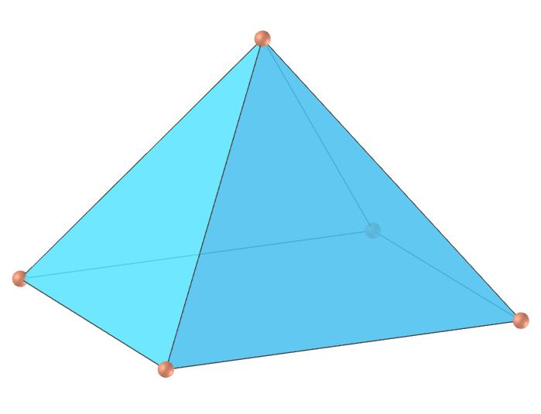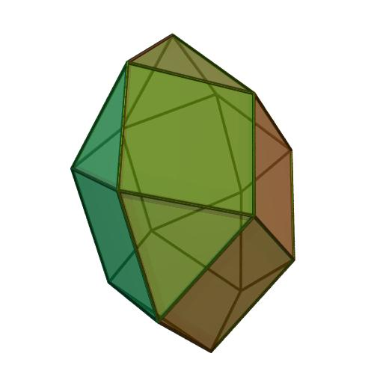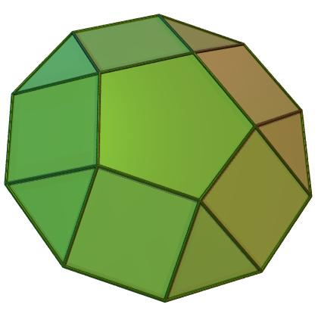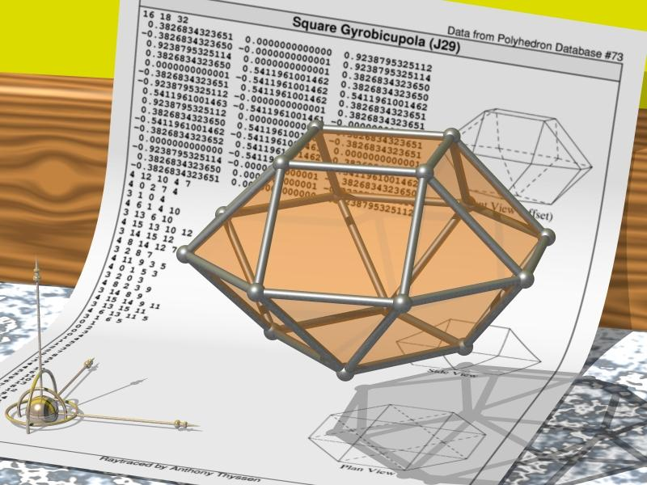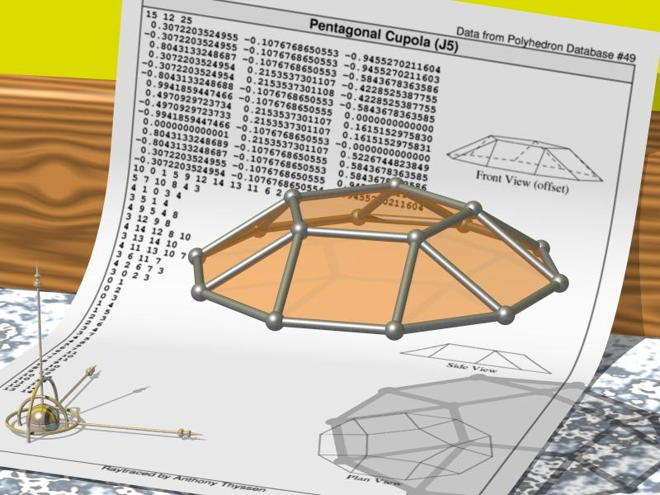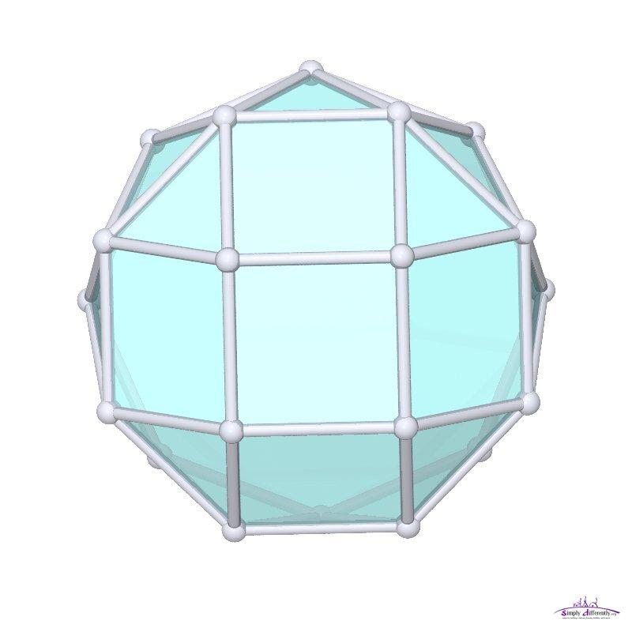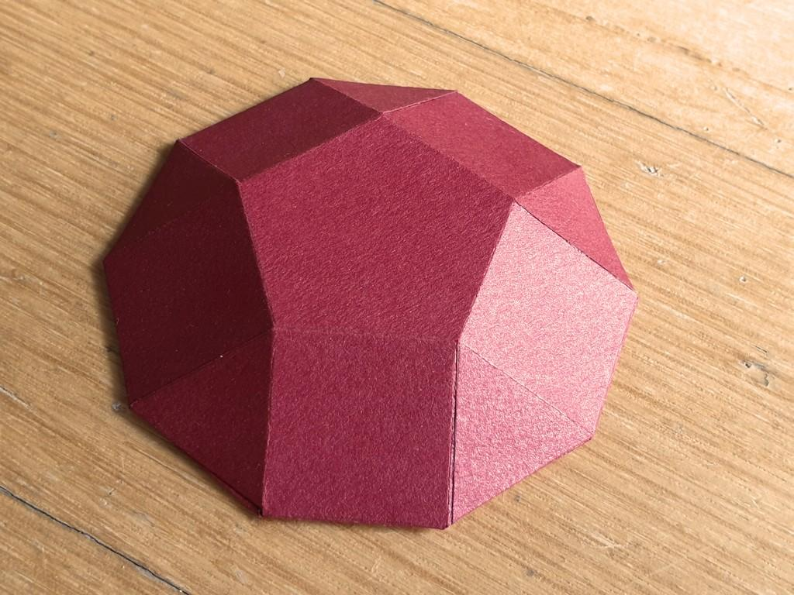

Main Characteristics
# Source: AI Source: Provided by: [Data Path: Persons Table -> ID Column: 1, Name_En Column: Motasem Essam] -> From: [ChatGPT] on [7/25/2026]
- Regular Polygonal Faces: Every face is a regular polygon, such as an equilateral triangle, square, or regular pentagon.
- Non-Uniform Vertex Arrangement: The vertices are not all equivalent under the solid's symmetry operations.
- Different Vertex Configurations: Different vertices may have different combinations or arrangements of faces.
- Convex Geometry: The classical category discussed here consists of convex polyhedra.
- Variable Symmetry: A solid may possess rotational or reflectional symmetry without being vertex-transitive.
- Equal Edge Lengths: In the classical Johnson-solid classification, all edges have equal length.
- Multiple Face Types: A single solid may contain several kinds of regular polygons.

Types of Non-Uniform Regular-Faced Polyhedra

Johnson Solids
# Source: AI Source: Provided by: [Data Path: Persons Table -> ID Column: 1, Name_En Column: Motasem Essam] -> From: [ChatGPT] on [7/25/2026]
Johnson Solids are convex, non-uniform polyhedra whose faces are regular polygons and whose edges have equal lengths.
They are named after mathematician Norman Johnson, who catalogued 92 such solids in 1966. Victor Zalgaller subsequently proved that the list is complete.
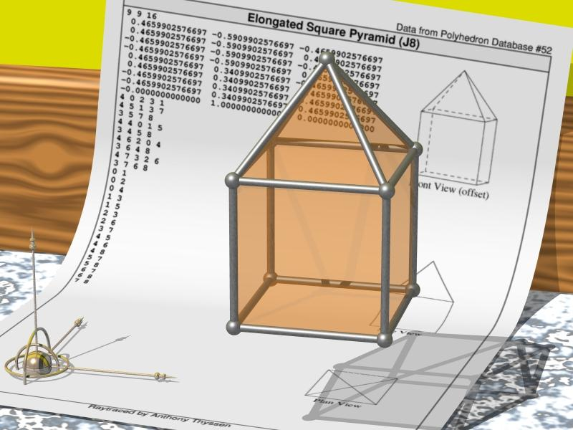
The 92 Johnson solids are conventionally numbered from J1 to J92.
Examples:
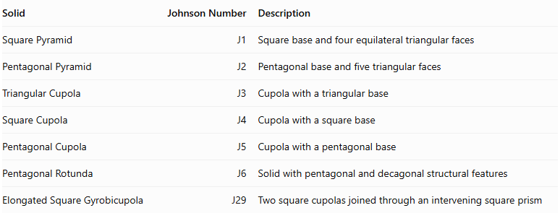
Solid | Johnson Number | Description
Square Pyramid | J1 | Square base and four equilateral triangular faces
Pentagonal Pyramid | J2 | Pentagonal base and five triangular faces
Triangular Cupola | J3 | Cupola with a triangular base
Square Cupola | J4 | Cupola with a square base
Pentagonal Cupola | J5 | Cupola with a pentagonal base
Pentagonal Rotunda | J6 | Solid with pentagonal and decagonal structural features
Elongated Square Gyrobicupola | J29 | Two square cupolas joined through an intervening square prism

Other Non-Uniform Regular-Faced Polyhedra
# Source: AI Source: Provided by: [Data Path: Persons Table -> ID Column: 1, Name_En Column: Motasem Essam] -> From: [ChatGPT] on [7/25/2026]
This category can describe regular-faced polyhedra that are not included in the standard 92 Johnson solids, depending on the classification convention being used.
Examples discussed in mathematical literature include:
- Triangular Dipyramid: Two triangular pyramidal portions joined at a triangular base.
- Pentagonal Dipyramid: Two pentagonal pyramidal portions joined at a pentagonal base.
- Snub Disphenoid: A convex solid formed from eight equilateral triangles with a disphenoidal arrangement.
- Siamese Dodecahedron: A special regular-faced polyhedron discussed in early classifications.
These examples are useful when studying the broader category of regular-faced non-uniform polyhedra. However, some classifications include particular examples in the Johnson-solid list or use different naming conventions.

Classification by Structure and Construction
# Source: AI Source: Provided by: [Data Path: Persons Table -> ID Column: 1, Name_En Column: Motasem Essam] -> From: [ChatGPT] on [7/25/2026]
Non-uniform regular-faced polyhedra can also be organized according to how their faces and components are arranged.

Elementary Regular-Faced Polyhedra
# Source: AI Source: Provided by: [Data Path: Persons Table -> ID Column: 1, Name_En Column: Motasem Essam] -> From: [ChatGPT] on [7/25/2026]
An Elementary Regular-Faced Polyhedron cannot be divided by a suitable plane into two smaller regular-faced polyhedra sharing a common face.
Examples include:
- Square pyramid.
- Pentagonal pyramid.
- Certain cupolas and rotundas.
- Certain diminished polyhedra.

Composite Regular-Faced Polyhedra
# Source: AI Source: Provided by: [Data Path: Persons Table -> ID Column: 1, Name_En Column: Motasem Essam] -> From: [ChatGPT] on [7/25/2026]
A Composite Regular-Faced Polyhedron can be formed by joining two or more regular-faced polyhedral components along matching polygonal faces.
Examples of construction operations include:
- Joining polyhedra.
- Augmenting a polyhedron with pyramids or cupolas.
- Diminishing a polyhedron by removing components.
- Elongating a polyhedron using a prism.
- Gyrating components before joining them.

Mathematical Characteristics
# Source: AI Source: Provided by: [Data Path: Persons Table -> ID Column: 1, Name_En Column: Motasem Essam] -> From: [ChatGPT] on [7/25/2026]
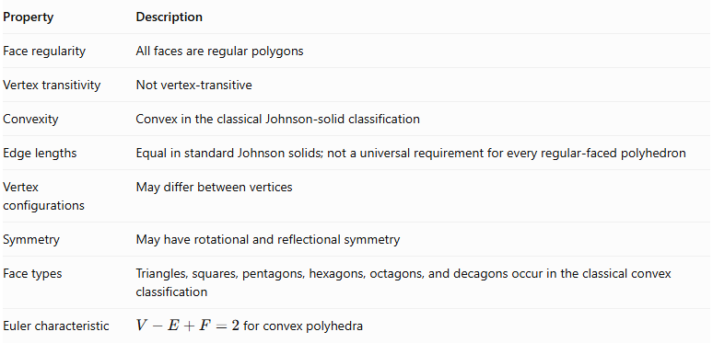
Property | Description
Face regularity | All faces are regular polygons
Vertex transitivity | Not vertex-transitive
Convexity | Convex in the classical Johnson-solid classification
Edge lengths | Equal in standard Johnson solids; not a universal requirement for every regular-faced polyhedron
Vertex configurations | May differ between vertices
Symmetry | May have rotational and reflectional symmetry
Face types | Triangles, squares, pentagons, hexagons, octagons, and decagons occur in the classical convex classification
Euler characteristic | $V-E+F=2$ for convex polyhedra

Number of Non-Uniform Regular-Faced Polyhedra
# Source: AI Source: Provided by: [Data Path: Persons Table -> ID Column: 1, Name_En Column: Motasem Essam] -> From: [ChatGPT] on [7/25/2026]
The standard Johnson-solid classification contains exactly 92 solids.
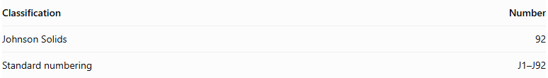
Classification | Number
Johnson Solids | 92
Standard numbering | J1–J92
The broader mathematical category of non-uniform regular-faced polyhedra is not necessarily limited to these 92: its scope depends on whether equal edge lengths, convexity, and particular construction conventions are required.

Comparison: Uniform vs. Non-Uniform Regular-Faced Polyhedra
# Source: AI Source: Provided by: [Data Path: Persons Table -> ID Column: 1, Name_En Column: Motasem Essam] -> From: [ChatGPT] on [7/25/2026]
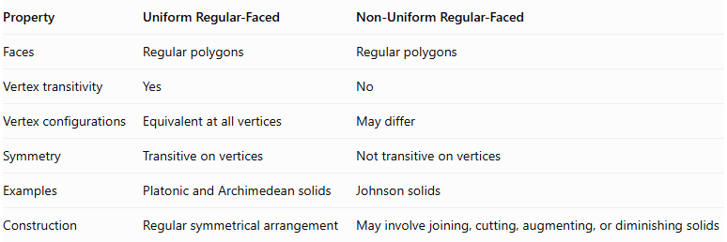
Property | Uniform Regular-Faced | Non-Uniform Regular-Faced
Faces | Regular polygons | Regular polygons
Vertex transitivity | Yes | No
Vertex configurations | Equivalent at all vertices | May differ
Symmetry | Transitive on vertices | Not transitive on vertices
Examples | Platonic and Archimedean solids | Johnson solids
Construction | Regular symmetrical arrangement | May involve joining, cutting, augmenting, or diminishing solids

Related Geometric Solids
# Source: AI Source: Provided by: [Data Path: Persons Table -> ID Column: 1, Name_En Column: Motasem Essam] -> From: [ChatGPT] on [7/25/2026]
- Johnson Solids – The 92 standard convex non-uniform regular-faced polyhedra.
- Uniform Polyhedra – Polyhedra with regular faces and vertex transitivity.
- Cupolas – Solids with alternating triangular and square lateral faces.
- Rotundas – Polyhedra with a characteristic arrangement of triangular and pentagonal faces.
- Augmented Polyhedra – Polyhedra formed by attaching additional components.
- Diminished Polyhedra – Polyhedra formed by removing selected components.
- Gyroelongated Polyhedra – Solids formed by combining components with an intervening antiprismatic structure.

Main Classification
# Source: AI Source: Provided by: [Data Path: Persons Table -> ID Column: 1, Name_En Column: Motasem Essam] -> From: [ChatGPT] on [7/25/2026]
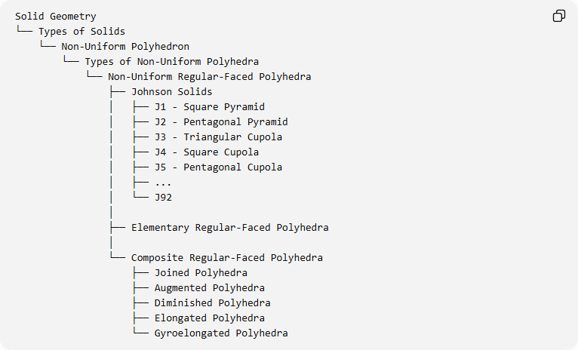
Solid Geometry
└── Types of Solids
└── Non-Uniform Polyhedron
└── Types of Non-Uniform Polyhedra
└── Non-Uniform Regular-Faced Polyhedra
├── Johnson Solids
│ ├── J1 - Square Pyramid
│ ├── J2 - Pentagonal Pyramid
│ ├── J3 - Triangular Cupola
│ ├── J4 - Square Cupola
│ ├── J5 - Pentagonal Cupola
│ ├── ...
│ └── J92
│
├── Elementary Regular-Faced Polyhedra
│
└── Composite Regular-Faced Polyhedra
├── Joined Polyhedra
├── Augmented Polyhedra
├── Diminished Polyhedra
├── Elongated Polyhedra
└── Gyroelongated Polyhedra
Classification note: These are useful structural and construction-based subdivisions, not a universally standardized partition of all non-uniform regular-faced polyhedra.

Key Points
# Source: AI Source: Provided by: [Data Path: Persons Table -> ID Column: 1, Name_En Column: Motasem Essam] -> From: [ChatGPT] on [7/25/2026]
- Non-uniform regular-faced polyhedra have regular polygonal faces but are not vertex-transitive.
- The 92 Johnson solids are the principal classical examples.
- Johnson solids are convex and have equal edge lengths.
- Different vertices may have different face arrangements.
- These polyhedra can be elementary or assembled from multiple geometric components.
- Regular faces do not necessarily imply uniformity.

Conclusion
# Source: AI Source: Provided by: [Data Path: Persons Table -> ID Column: 1, Name_En Column: Motasem Essam] -> From: [ChatGPT] on [7/25/2026]
Non-Uniform Regular-Faced Polyhedra are an important category of polyhedra that preserve regularity at the face level without having uniform vertex arrangements. The 92 Johnson solids form their best-known classical family, including pyramids, cupolas, rotundas, augmented solids, diminished solids, and elongated solids.

